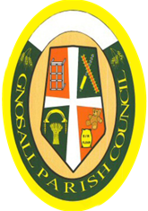

NOTICE IS HEREBY GIVEN that the
ANNUAL PARISH ASSEMBLY
will be held on Wednesday 17th May 2023
in the Grosvenor Centre, High Street, Gnosall
Commencing at 7.30pm

A G E N D A

1 To receive apologies

2 To receive the minutes of the last meeting held on 26th May 2023

3 To receive a short report from the Chair of the Parish Council

4 To receive reports from the Borough and County Councillors

5 To welcome Staffordshire’s Police Fire and Crime Commissioner, Ben Adams

6 To receive any questions from electors

Closure of the meeting will be followed by refreshments.

This is the annual opportunity for the local community to put questions or concerns formally to the Parish Council and meet its Parish, Borough and County Councillors.

If any resident has a specific item they wish discussed, please contact the Parish Clerk by 15th May 2023

Annual Reports for the year 2022/23 will be available at the Annual Assembly

Allan Mills

Chair, Gnosall Parish Council Dated 3rd May 2023

